**Demonstrate how to run a Collection using Collection Runner**

Step-1:

First open postman

Step-2:

Then I click on “+” sign to create a collection

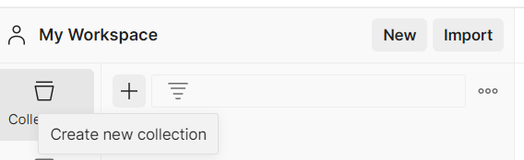

Step-3:

Then I click on Blank Collection

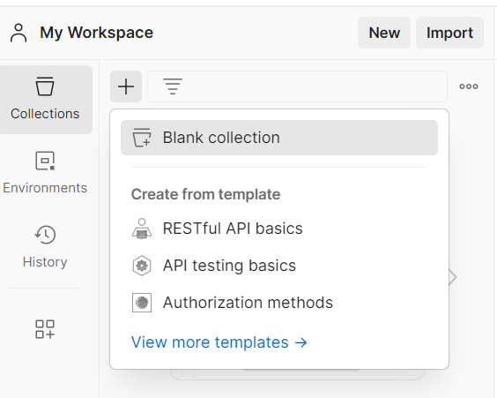

Step-4:

Then I click on 3 dot then select Add request

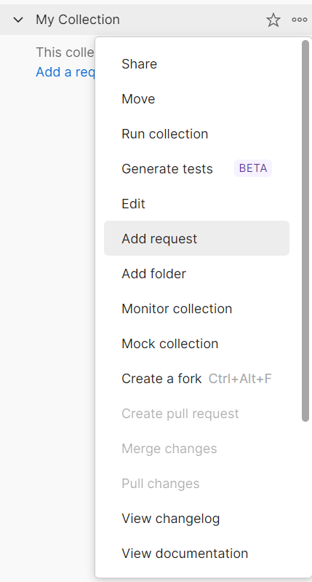

Step-5:

Then I rename it and enter request url

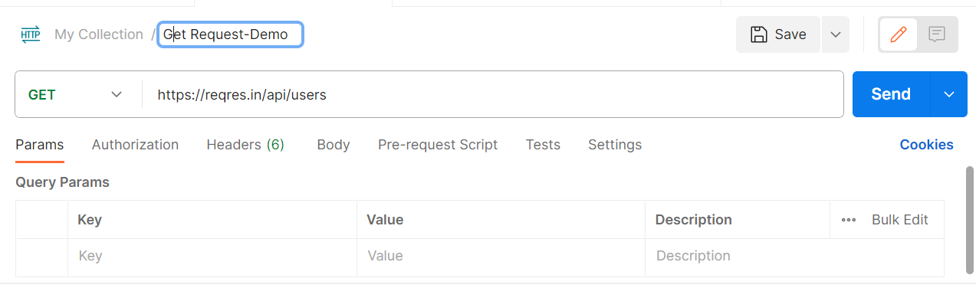

Step-6:

Then I create another request

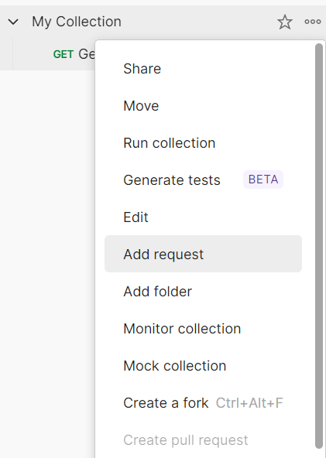

Step-7:

Then I enter url

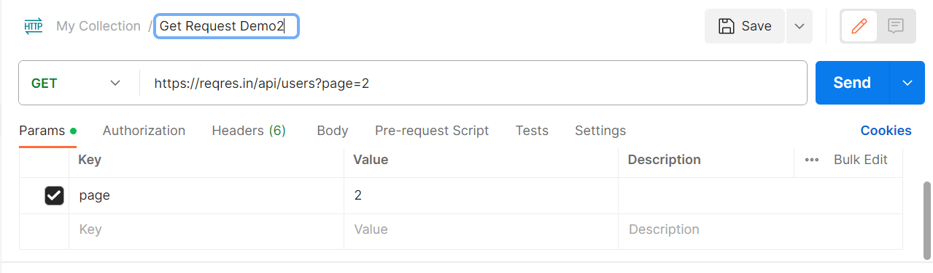

Step-8:

Then I click on 3 dot and then click on Run collection

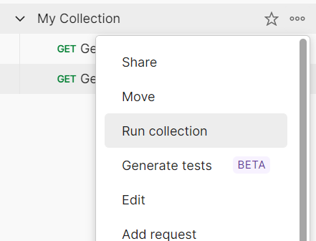

Step-9:

Then I click on Run my collection

